

B00256311 Victoria Russell

COMP09085: Mobile Games Development



25th March 2016

By Victoria Russell

B00256311

Contents

Game Overview 2

Target Audience 2

Target Platform 2

Code Framework 2

Project Management 3

Navigation 4

Game Mechanics & Layout 5

Possible Issues 6

Future Development 6

# Game Overview

For this module, I will be developing a match 3 game in 2D, similar to such games as Candy Crush Saga and Farm Hero Saga. The player would be able to traverse through different levels of various board sizes and shapes. The board will be split up into rows and columns with one object in each space. The layer will be able to match 3 or more objects that are together either horizontally or vertically. My aim would be to also attempt to open the game’s progression, to have similar RPG game mechanics such as Puzzle Quest & Puzzle Dragons. I intend to do this by using a simple battle scene where the player can only attack by the amount of objects they were able to match. However this will be determined depending on time constraints. In attempt to not over-exhaust my time, I will aim to keep the battle scene simple.

# Target Audience

I aim to develop the game for an age group of 7 plus and for those who enjoy a combination of puzzle casual based games and RPG type games.

# Target Platform

For initial development, the aim will be to produce the game that could be playable on a web browser either on PC or on mobile.

# Code Framework

The game will be developed in Javascript with HTML5. However, for the purpose to keep the game as less time consuming and as simple as possible, the game will be made using Webstorm with possibly also using the Phazer framework. I hope to maybe look into the possible use of implementing WebGL shaders. However, this is depending on time constraints.

# Project Management

Currently I have decided to do this as a sole project as my other colleagues have already paired off. So not only would I be doing all of the programming but I aim to also reduce the amount of artwork by outsourcing from free resource websites. Some artwork will be done by myself with the use of Adobe Photoshop. My main milestones over the next 5 weeks:

By 1st April – Have initial scene & navigation setup. Final design decisions will be finalised and scene layout will be fully designed to be ready for implementation.

By 8th April – Using placeholder art for now, initial game mechanics for the match 3 board will be started. Also work on some art to be used, either by hand or outsourced.

By 15th April – Implement basic battle scene and show that the amount of objects matched will be affecting how the player attacks. More artwork will be done as necessary and put in place. The core game mechanics will be implemented and worked on.

By 22nd April – Hoping to use this week to fix the majority of bug fixing and as well as implement any advancements within the game mechanics and code structure. Finishing off any artwork required for the game.

By 29th April – Game would be finished with majority of bugs fixed. Documentation will be written up and game prototype will be submitted for deadline.

Since this will be a sole project, the game’s progress will be recorded via the online GitHub repository as it also has inbuilt Wiki, so I can easily show my progress using a simple blog page. This repository can be accessed by:

https://github.com/viscountess/B00256311_Mobile_GameDev_Project

# Navigation

I aim to employ a simple screen navigation as follows:

Game Exit

Lose State

Win State

Game Level

New Game

Instructions/How to Play

Credits

Main Menu

Pause Menu

The blue boxes and arrows will be the basic implementation, whereas red indicates some more advanced navigation that will be implemented dependant on time constraints. So from the main menu, the player should be able to navigate to the Credits and Instructions screen and then back to the Main Menu. From the Main Menu also, the player will be able to start a new game, which will begin the main game level. From here, the player could either win or lose depending on the outcome of the gameplay. Player will be able to go back to main menu to start over. The player will also be able to exit from the main menu.

# Game Mechanics & Layout

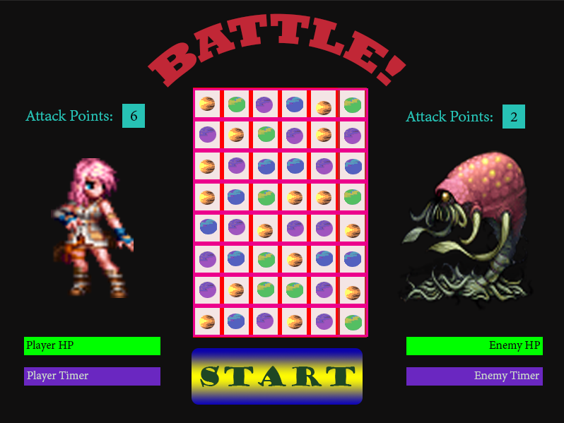

The basic game layout of what I hope to achieve, will look similar to the picture above. The player will have to match at least 3 or more attack symbols to accumulate attack points. For example, this will be represented by the yellow symbol. The player will attack the enemy when the player timer is full. The attack power will be determined by the number of attack points the player has managed to accumulate. After the attack is made, the player timer will refresh, and the player would need to wait until the timer reaches full again before he/she can attack.

The enemy could also accumulate attack points when the player matches three or more of the enemy symbol, for example the green symbol. When the enemy timer reaches maximum, the enemy will have a basic attack, but can be boosted by accumulated attack points. Similar to the player, the enemy timer will refresh once the attack has been done and the enemy won’t be able to attack until the timer is full again. The player will lose if the player’s health (HP) reaches zero, and the player will win if the enemy’s health (HP) reaches zero.

# Possible Issues

The main issue that could arise is not being able to have the match 3 puzzle working with rpg element of the gameplay. This could be communication issues within the code for example, the amount of attack points not updating correctly. Another possible issue would be to have the attack and timer ratio, not working efficiently. For example, the timer could be really slow and the damage isn’t much, which could make the game too long, which would make the player bored. A lot of these issues could be prevented as much as possible by doing regular testing throughout the development phase. Either by automated testing or have other testers to play the game to give feedback. The design of the game will be re-evaluated at every milestone. Incase of the implementation of a feature would be too complicated and needs to be simplified or disregarded completely.

# Future Development

I aim to have the game ready for expansion, or have the possibility to advance the game mechanics. Either as future development or as time permitted before deadline. For example, I could advance the player’s attack variety by allowing the player to cast spells. So similar to the attack points, players can accumulate mana points by matching three or more of the blue symbol for example. I could also have a random buff symbol that appears in the grid and if the player matches 3 or more of the buff symbol then I could apply various enhancements for the players. For example a temporary speed boost of the player’s timer or regeneration of some of the player’s HP.

I could also have the player to choose his or her own character, and possibility have different stats for each character. I could do this by adding in a character selection screen. And also have random monster fights, again with each enemy having its own stats. I would also like to implement a random match three grid of different shapes. Again this is to add replay-ability and variety to the game.

To enhance the game visually, I would also add in some small visual ques. For example, the player would do an attack animation and maybe other animations to represent other states like idle, winning, or death for both the player and the enemy. As well as sounds for audio ques and some background music.